**QUE:-1**

* **HTML**

**<!DOCTYPE html>**

**<html lang="en">**

**<head>**

**<meta charset="UTF-8">**

**<meta name="viewport" content="width=device-width, initial-scale=1.0">**

**<title>CSS Selectors Example</title>**

**<link rel="stylesheet" href="styles.css">**

**</head>**

**<body>**

**<h1>Welcome to My Website</h1>**

**<p class="intro">This is an introduction paragraph.</p>**

**<p>This is a normal paragraph.</p>**

**<div id="main-container">**

**<h2>Main Section</h2>**

**<p>This is inside the main container.</p>**

**<a href="#">Click Here</a>**

**</div>**

**<ul>**

**<li>Item 1</li>**

**<li class="highlight">Item 2</li>**

**<li>Item 3</li>**

**</ul>**

**</body>**

**</html>**

* **CSS (styles.css)**

**\* {**

**font-family: Arial, sans-serif;**

**}**

**h1 {**

**color: blue;**

**text-align: center;**

**}**

**.intro {**

**font-size: 18px;**

**color: green;**

**}**

**#main-container {**

**background-color: lightgray;**

**padding: 15px;**

**border-radius: 5px;**

**}**

**#main-container p {**

**color: darkred;**

**}**

**OUTPUT:-**

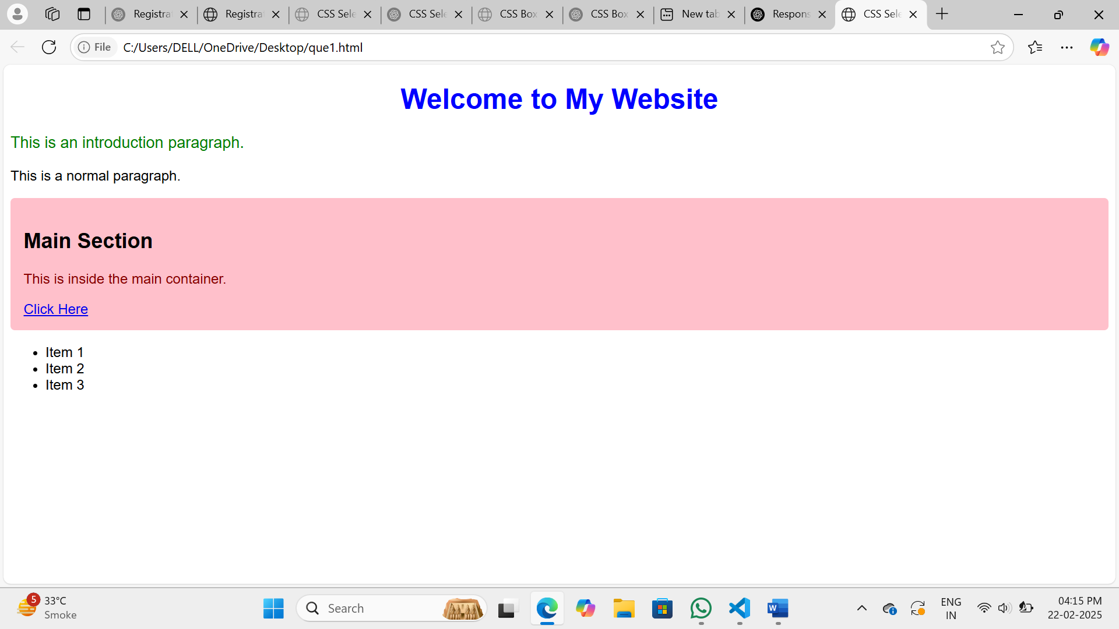

**QUE:-2**

**<!DOCTYPE html>**

**<html lang="en">**

**<head>**

**<meta charset="UTF-8">**

**<meta name="viewport" content="width=device-width, initial-scale=1.0">**

**<title>CSS Box Model</title>**

**<style>**

**.box {**

**width: 300px;**

**border: 5px solid black;**

**padding: 20px;**

**margin: 30px;**

**background-color: lightblue;**

**}**

**</style>**

**</head>**

**<body>**

**<div class="box">**

**<h2>Box Model Example</h2>**

**<p>This is an example demonstrating the CSS Box Model with margin, border, padding, and content.</p>**

**</div>**

**</body>**

**</html>**

**OUTPUT:-**

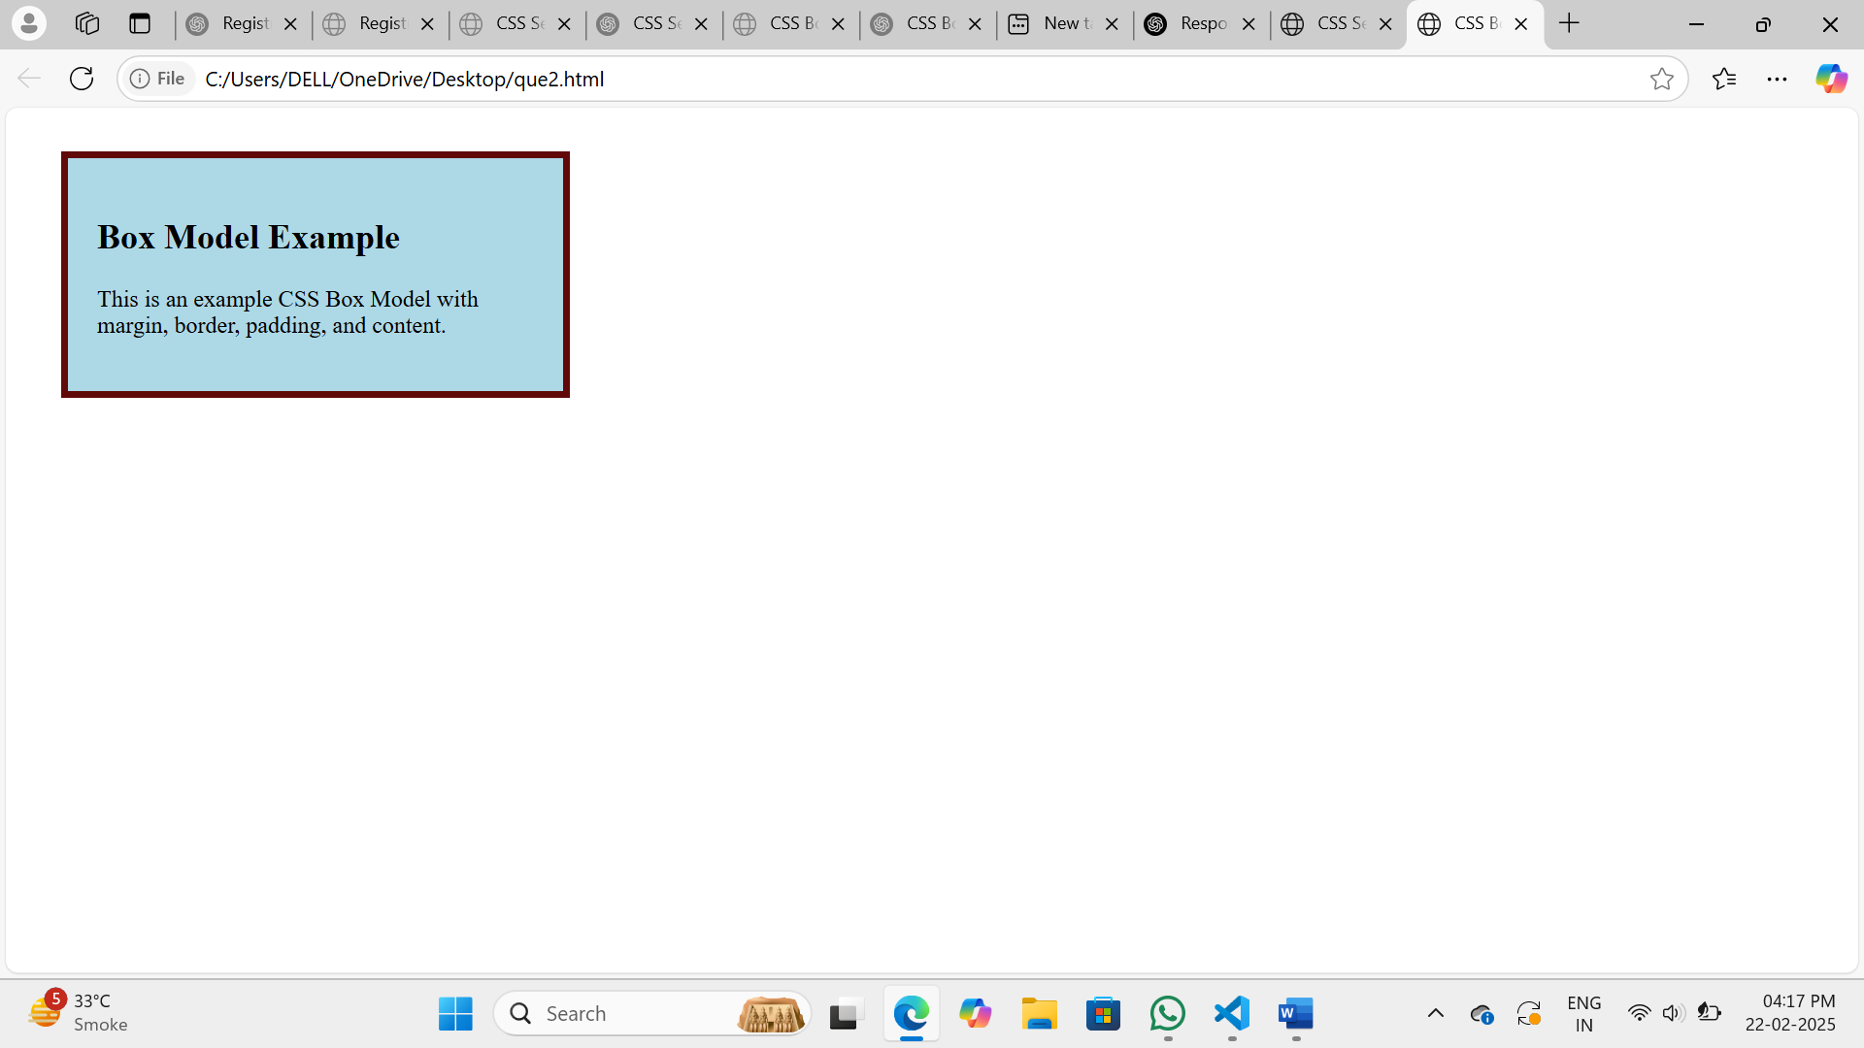

**QUE:-3**

**<!DOCTYPE html>**

**<html lang="en">**

**<head>**

**<meta charset="UTF-8">**

**<meta name="viewport" content="width=device-width, initial-scale=1.0">**

**<title>Registration Form</title>**

**<style>**

**body {**

**display: flex;**

**justify-content: center;**

**align-items:center;**

**height:100vh;**

**background-color: #f0f8ff;**

**}**

**.container {**

**background: white;**

**padding: 20px;**

**border-radius: 10px**

**width: 300px;**

**}**

**.container h2 {**

**text-align: center;**

**}**

**.form-group {**

**margin-bottom: 10px;**

**}**

**.form-group label {**

**display: block;**

**}**

**.buttons {**

**text-align: center;**

**}**

**</style>**

**</head>**

**<body>**

**<div class="container">**

**<h2>Registration Form</h2>**

**<form>**

**<div class="form-group">**

**<label for="name">Name:</label>**

**<input type="text" id="name" name="name" required>**

**</div>**

**<div class="form-group">**

**<label>Gender:</label>**

**<input type="radio" name="gender" value="Male"> Male**

**<input type="radio" name="gender" value="Female"> Female**

**</div>**

**<div class="form-group">**

**<label>Interests:</label>**

**<input type="checkbox" name="interest" value="Sports"> Sports**

**<input type="checkbox" name="interest" value="Music"> Music**

**<input type="checkbox" name="interest" value="Reading"> Reading**

**</div>**

**<div class="form-group buttons">**

**<button type="submit">Submit</button>**

**<button type="reset">Reset</button>**

**</div>**

**</form>**

**</div>**

**</body>**

**</html>**

**OUTPUT:-**

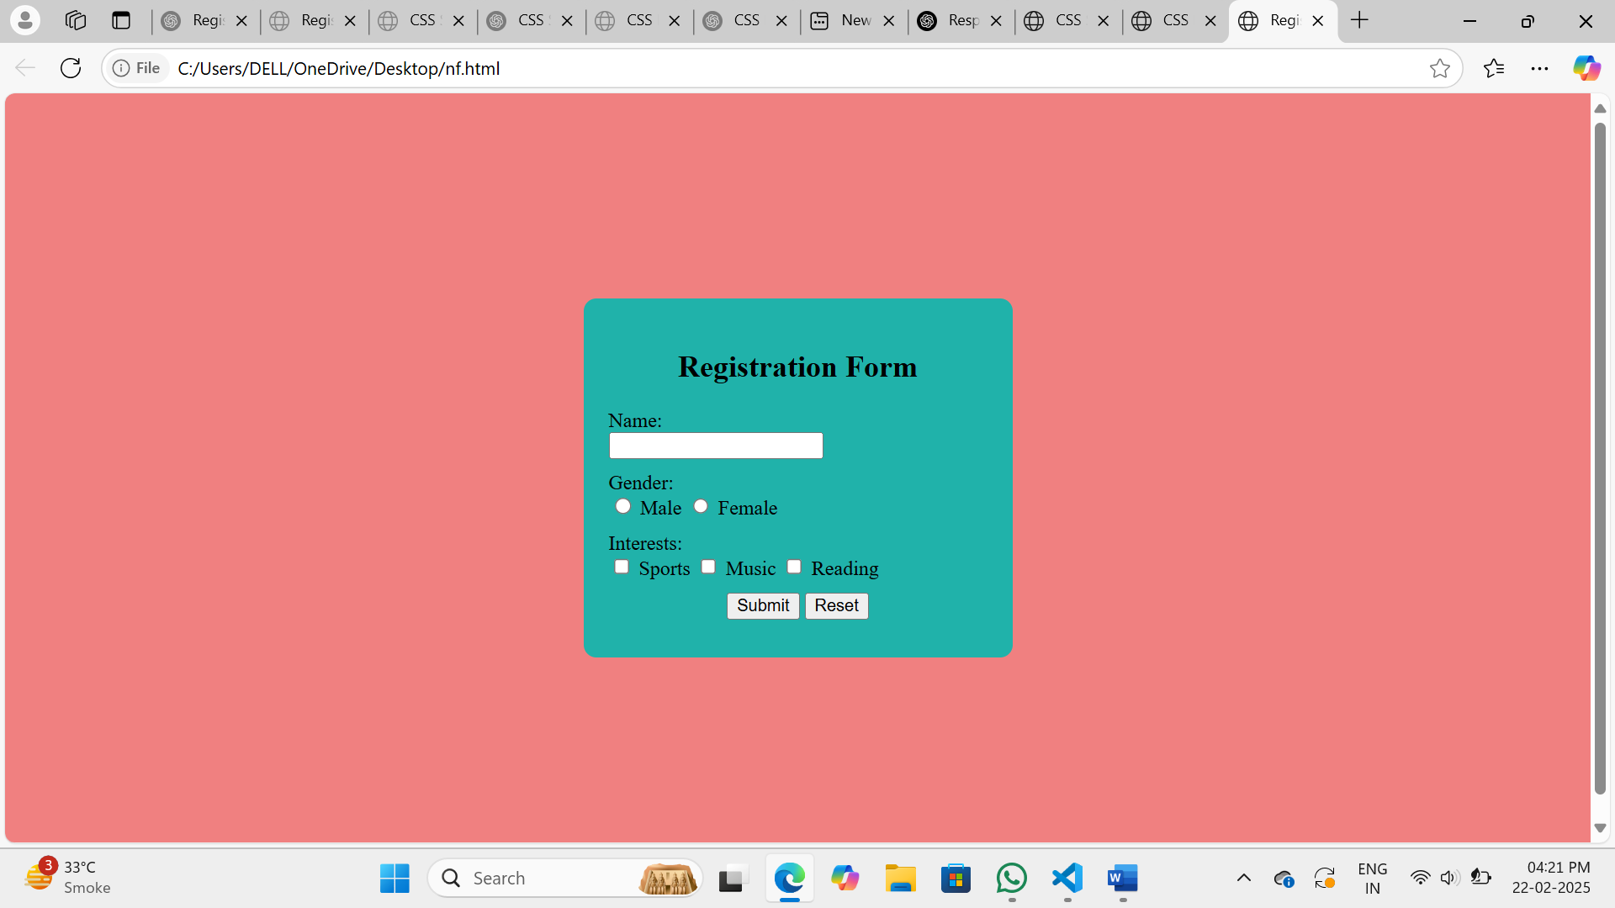

**QUE:-4**

* **HTML**

**<!DOCTYPE html>**

**<html lang="en">**

**<head>**

**<meta charset="UTF-8">**

**<meta name="viewport" content="width=device-width, initial-scale=1.0">**

**<title>Responsive Design with Media Query</title>**

**<link rel="stylesheet" href="styles.css">**

**</head>**

**<body>**

**<div class="content">**

**<h1>Responsive Text and Background</h1>**

**<p>Resize the screen to see the changes!</p>**

**</div>**

**</body>**

**</html>**

* **CSS (styles.css)**

**body {**

**background-color: white;**

**font-family: Arial, sans-serif;**

**font-size: 18px;**

**text-align: left;**

**margin: 0;**

**padding: 20px;**

**}**

**.content {**

**max-width: 800px;**

**margin: auto;**

**}**

**@media (max-width: 600px) {**

**body {**

**background-color: lightblue;**

**font-size: 16px;**

**text-align: center;**

**}**

**}**

**@media (min-width: 601px) and (max-width: 900px) {**

**body {**

**font-size: 20px;**

**}**

**}**

**@media (min-width: 901px) {**

**body {**

**font-size: 22px;**

**}**

**}**

**OUTPUT:-**

